I am writing again because of another hacked game I came upon, this time a hacked Earthbound cartridge. From my previous encounter with Slenderman The Game I felt a little uneasy of buying another cartridge, but since it was near Halloween I decided to buy one to see what it's like. It happened to be a hacked Earthbound and a normal Earthbound Cart at the local fleemarket. However I did forget to ask where the seller obtained the cart which didn't bother me much later. The bootleg was on a blank SNES cartridge with "Earthbound" written in red sharpie as seen in the only obtainable picture to the right. This is due to not having the proper recording software for the gameplay and I have no equipment to dump a SNES rom atm but it may be possible in the future. The price for the bootleg was $8 while the official game was $50, a steal because I was able to get it before the filthy resellers could. 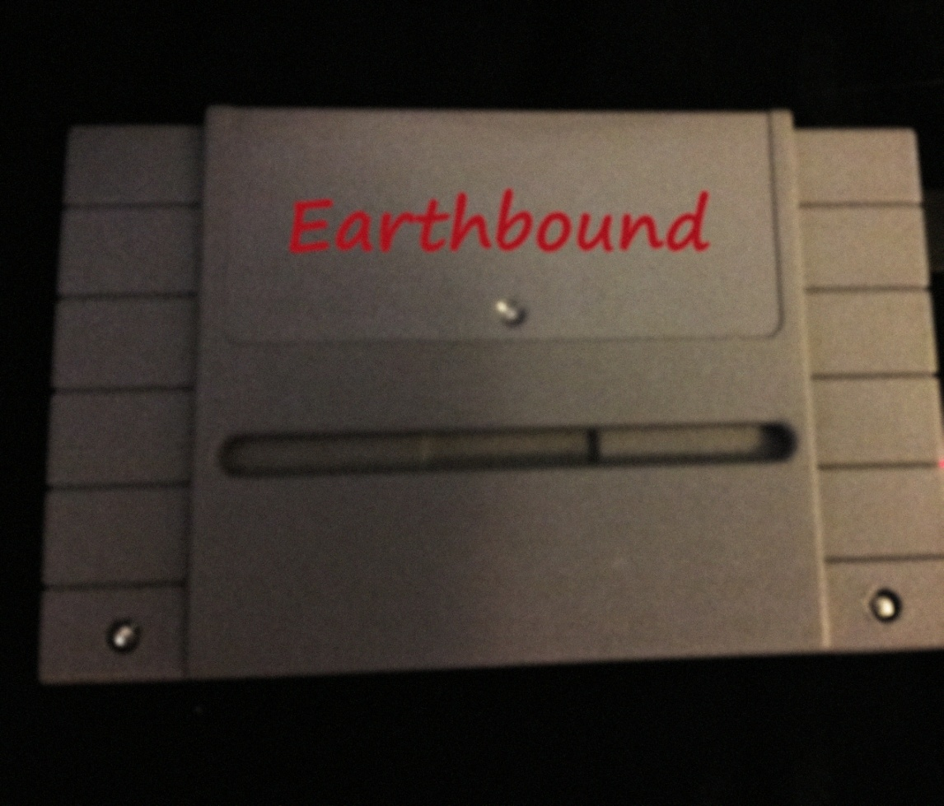
When I brought the game home the SNES first locked out the cart. To counter this I made a cartridged specialized to bypass the lockout chip for my hacked games. I succeeded and was greeted to the games 1st intro which was unchanged.
Now, many things are capable using hacks, for example changing color palettes, sounds, and sprites. This can make custom plots, characters, and entirely new games.
So, it came to no surprise that the intro after I started a new game was edited to show burning houses, demonic 16-bit sounds, and the music to the Sonic CD's boss battles (yea that creepy song.) With a story that said this.
"In 199x, in a small town in America, the evil demon Giygas was unleased. He destroyed the town and soon spread throughout the land. The only one left alive was a small boy named Ness. However, Giygas had something in store for him in the near future..."
Ness awoke to the sight of his half destroyed house. As I walked to the door a text box appeared.
"It is quiet except for the sound of burning wood. Something has happened to your family, your town, and soon... You... Get dressed and leave QUICKLY!"
The screen faded out and in to Ness now dressed with his clothes slightly chared. I navigated through the wreckage of the house and stumble into the sister's room. There I find a present with the item "bloody bat", I equipped it and realized that the present was next to a mutilated sprite of Ness's sister.
The corpse from what I could tell looked bitten and scratched, as if by some animal, and fought the foe off with the bat. I saw a trail of blood leading out the door and followed it downstairs.
There I found the bodies of Ness's Mom and their dog, King, who looked rabid and as if he was beaten with a blunt object. the Mom looked the same as Ness's sis did, torn up from bite marks and scratches, making it obvious what had happened.
Ness was staring at the mess locked in place like a cutscene for a minute before returning to normal. Then I noticed the music... It was the Onett theme in reverse with occasional changes in pitches and speed and this continued through both Ness's house and in Onett. This scene was both sad and erie at the same time mixing my emotions greatly.
Searching around the area of Ness's house and Onett I noticed Porkey's house was completely gone as if it didn't exist which for some reason felt a little odd to me. Also the Treasure Hunter's house was destroyed with his dead body nearby, burnt. At the top of the hill there was no meteorite but a burning tree with several dead bodies around. After finding little in Onett except for the dead mayor and blood covered hospital I went to Twoson and never found one enemy. The music changed to the same kind of corruption Onett had but this time it was Twoson's theme, made sense. In the town the only noticible thing was that there were less dead bodies than in Onett implying that this destruction was spreading slowly. After I started advancing through to the next town I noticed that there was less and less destruction till the game started playing fine again. The only thing was that I was underpower now and still had no companions. In fact, There were no companions, as if they had been erased from the plot entirely leaving me alone.
When I got to summer everyone was noticebly gloomy, The Runaway five were getting ready to leave the town and said to Ness "Run", "Drive", "Swim", "Don't", "Stop" in order of left to right. After this point some NPC's were telling Ness strange things like "Your running out of time" and "Your too slow, you'll kill us all." So I left Summer as soon as I could without having to do any quests. In fact, all I had to do was walk directly to the end.
As the game progressed things became drearier from the fact of impending doom for the characters. The music tracks progressivly became more depressing the farther in game I went and colors started to fade into black and white. Sprites had more and more depressing facial expressions as well. Just think of the knowledge that your inevitable death is soon as if you are on death row and that was what the characters were thinking.
By the time I made it to Saturn Valley which had my most favorite song was in reverse and slowed, the game was also completely black and white. Mr. Saturn was frowning and almost crying with antenna drooped saying nothing. Then it was time to go back in time as a robot. When I entered Giygas's lair I noticed that my robot looked worn and beat. I had no chance of winning.
When I entered the boss room Porky right away sent out Giygas without saying a word and then dissapeared. While fighting Giygas he was saying more than just his usual dialoge. These included "You... have no help" "No... friends" "No family", "No prayers".
Inevitably I lost and instead of the retry screen it showed a cutscrene of the Earth being turned to fire. A caption below read "あなたが原因となっているものを見てください" "それはあなたのためではなかったしていた場合、ネスはそれを作っていただろう" Which translated out to "Look what you have caused." "If it hadn't have been for YOU Ness would have made it." Before cutting to black with the text "TO SLOW"
Just as I thought this was the end a loud 16-bit scream emitted from the TV as a image of a mutilated face of Ness appeared with the caption "YOUR FAULT!" I turned off the game as fast as I could not realizing that would happen. Now I still think about that image with the guilt of knowing I wasn't fast enough.
The game is now in my personal collection with no expectation of being played soon, although it is the most intriguing piece of my collection of the macabre of Nintendo...

